Community Hospitals Association Improving Practice

Innovation and Best Practice Award 2018 Summary
Title:
Scotter Ward Support Sessions
Background:
We were struggling to ensure that staff all had clinical supervision, had attended team meetings and how to effectively role out learning points from recent RCAs or Datix.

This was where the idea of the support sessions was born to provide a more time effective, efficient way of delivering the above than the present system we had.

We decided to expand it to a full day and add some relevant teaching sessions in.
Description:
We have developed a new way of supporting staff to ensure quarterly clinical supervision, attendance at staff meetings, ensure all staff attend mandatory bespoke to the ward training,
provide a forum to feedback and disseminate learning points from Datix and RCAs.

This gives staff an opportunity for dedicated discussion and support from peers and managers and protected time out from the ward setting.

The delivery of the sessions follows a format that means staff all have the sessions delivered in the space of 3 months over 3 sessions therefore reaching all clinical and non-clinical staff.

Time is saved as only one manager is needed to facilitate and not multiple one to ones.

There are no travel costs as the sessions are held on site.

Sessions delivered are in line with QUIPP initiatives. Sessions have been delivered on appropriate continence aid usage and how we can use more effectively and nutritional aids and falls risk assessment, effective prescribing, the new wound care formulary and more cost-effective dressing usage with reps coming in to demonstrate all the above.

We have included clinical nurse specialists from all areas including safeguarding, practitioner performance, continence, tissue viability and education. This has enabled the staff to meet these staff face to face and therefore feel able to approach these professionals and enhance and strengthen working relationships and be aware of the correct referral processes to ensure there are no delays in care.
Outcome and Impact:
Clinical Supervision and safeguarding supervision is now above compliance rates.

The new way of working in delivering clinical supervisions and teaching sessions in this way has benefits to patients by ensuring that the staff are out of practice for the minimum amount of time while ensuring that they up to date with the latest knowledge and learning takes place and has been disseminated from incidents.

It also gives the staff dedicated time out of practice to discuss issues and find new ways of working therefore valuing their opinions and input to help facilitate improvement and change and empowering decisions to ultimately improve patient care standards.

This idea has been shared at Inpatient Hospital Clinical Governance meetings and has now been adopted on the Welland Ward at Johnson Hospital very successfully. We have also shared on the wards Twitter site and ideas have been adopted by other wards in other areas It has been shared on many occasions resulting in increasing the profile and reputation of the trust.

It has also been featured on the FAB NHS Stuff website.
Supporting Information:
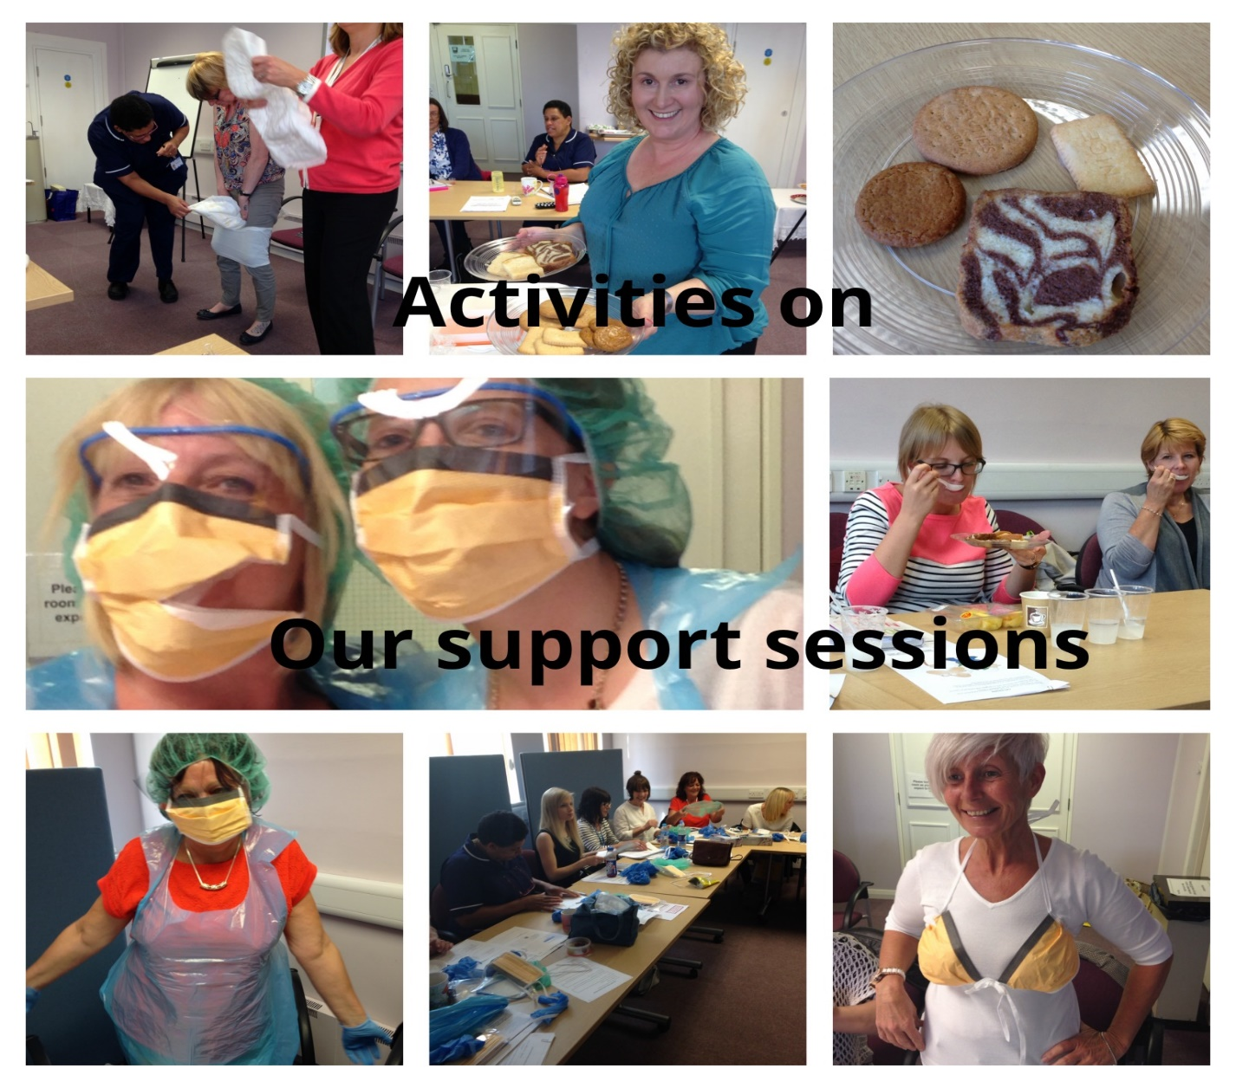
Organisation:
Scotter Ward
John Coupland Hospital
Lincolnshire Community Health Services
Contact details:
Donna Phillips
Clinical Team Lead
01427 816542
Donna.phillips@lincs-chs.nhs.uk
CHA Judges Comments:
The organisation of support sessions for staff is a creative way to support staff, within the work environment to meet the needs of patients and staff. We were impressed with the way in which this was organised and managed.

